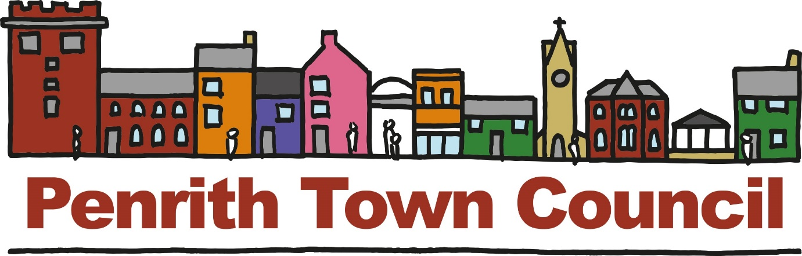

Press Release: Tuesday 30th July, 2019

‘Going for Gold - Britain in Bloom Judges visit Penrith.
Penrith’s volunteer gardeners and businesses are preparing for the RHS Britain in Bloom Judges visit to the town on Friday 2nd August. Chosen as a finalist in the highly respected RHS 2019 Britain in Bloom Competition, Penrith is currently enjoying an abundant display of beautiful blooms, shrubs and edibles.
Besides the beautiful plants, volunteer gardeners, other community organisations and business groups in Penrith are also very concerned about global issues such as declining pollinator populations, climate change and plastic waste. To help address these problems, many of the blooms chosen help to attract bees and other pollinators. Moreover, Penrith is lucky to have some wonderful green spaces, among which are Thacka Nature Reserve, Frenchfield Sports Centre, the woods and hillside around the Beacon and Fairhill. Many more trees are being planted on a regular basis to green the town even further. The ‘Plastic Clever Penrith’ campaign is also gathering pace and helping address the problem of single use plastic.
/enrith enjoys cross-community support from volunteers, various community groups, local businesses, the town council, which co-ordinates Penrith in Bloom, and other local government organisations. Close collaboration has increased feelings of pride in the town. However, there is always much more that can be done, and we would ask that everyone makes an effort to plant a flower, fruit bush or other edible in their garden, put out a pot of blooms by their front door and pick up any litter seen lying about and put it in an appropriate bin. All of this helps to make Penrith a well loved and beautiful town for those who live and work here.

