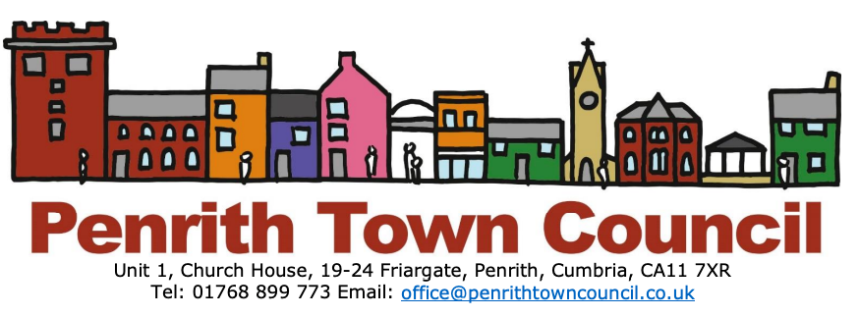
Community Support Grants

Penrith Town Council is supportive of the important work of community and voluntary groups and charities operating within the Town. We offer one-off community grants to these groups to help them achieve their aims.

Organisations can apply for amounts between £100 and £5000. However, applications for larger grants may be considered at a meeting of the full Town Council. In all cases, groups applying must be able to meet our criteria and demonstrate that any grant provided will be of some benefit to people living in Penrith.

To ensure fairness, transparency and accountability, we have clear guidelines. Grants will only be provided to recognised, bona-fide, non-profit making organisations or groups. However, grants cannot be made available to individuals, nor can they be made available to business or profit-making organisations. Limited companies may not apply. Completed applications will be considered by the Town Council’s ‘Community Culture and Economic Growth’ Committee whose decision will be final.

Examples of the town’s community and charitable organisations supported include: Triple A Project, Eden Mencap, NWAS Cardiac Smart Project, Penrith Pre Nursery, Penrith Credit Union, Penrith Remembers, Penrith Chamber of Trade, Fairhill Group, Carlton Park Group and Penrith Beekeepers among others.

Feedback from some of these groups providing insights into how each of them used the grants may be helpful to those thinking of applying for funds. Audio recordings of their presentations at the Annual Town Meeting on 20th May, 2019 are available on the ‘Podcasts and Videos’ Page of the Council Website (https://bit.ly/326DQR5).

For help or further information, please email: economicdevelopmentofficer@penrithtowncouncil.co.uk or call Carol on 01768 899773

