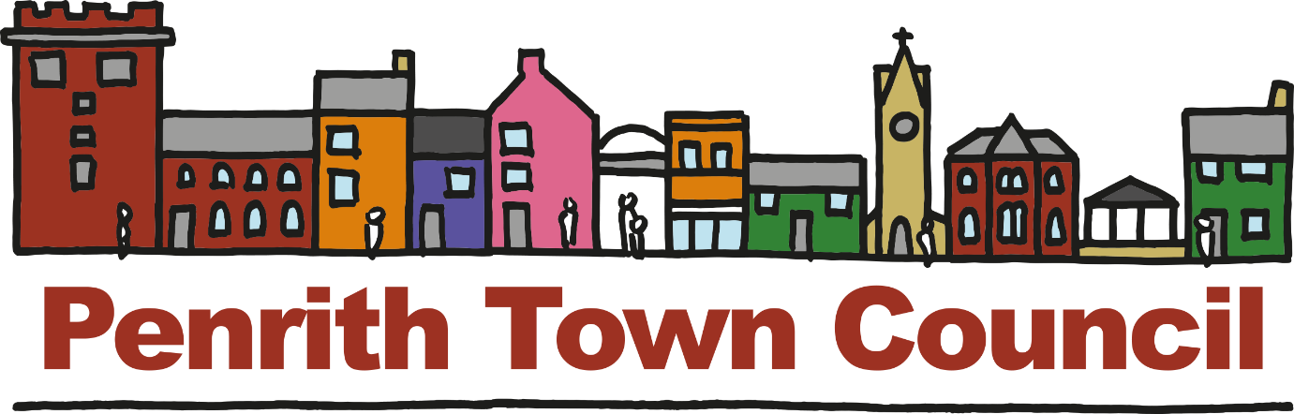

ANNUAL REPORT
2017-18

Have We Made A Difference?

Your Council
MAYOR’S REPORT

This has been a fascinating year for the Town Council as it develops into a mature local government body. I’ve always been excited by the aspirations of the members and officers, but this year has seen those aspirations start to become reality.
I am sure you will have read about our work on the neighbourhood plan and the enthusiasm I see to give residents a meaningful say in the planning process in the town is encouraging. Too often development is ‘done to’ rather than ‘done for’ residents and this document will give the security that our views are seriously listened to.
Likewise, devolution is starting to see the town’s assets owned by the town and thus far this includes the Cornmarket Bandstand and Fairhill playing field with added responsibility for War Memorials as well to go with our existing jurisdiction over the town’s allotments. More opportunities are being looked at and will be realised. Part of this process is the proper cataloguing of these assets, so we know precisely what we are custodians of and what we need to protect them.
We are also becoming more and more outward looking and I am particularly excited about our entry into Britain in Bloom, not only as an opportunity to showcase Penrith to the country but also to recognise and reinforce the great pride we have in our town, building on the effort already put in adding beauty to our streets and public spaces.
This isn’t the only community engagement we do however, and this year has seen numerous successful bids for funding and support from a diverse range of the town’s volunteer groups. It is the greatest honour to be able to help people who have the vision and passion to make a difference to the town and people’s lives.
It is not an exaggeration to say that some of the work people do in this town can make the difference between living and merely existing for huge numbers of residents and to help in any small way is something we strive for and are grateful to have the opportunity to do.
All of this can’t be done however without the dedication of our members and officers and I feel humbled that so many talented people want to work here and recognise the potential this council has.

I would like to finish with two votes of thanks, firstly to everyone at Penrith Town Council who gives their time, energy and imagination to the project; to the officers who go above and beyond and to the members who do all that they do on an entirely voluntary basis. And secondly, and perhaps more importantly, to all of you the residents for this opportunity to serve Penrith.

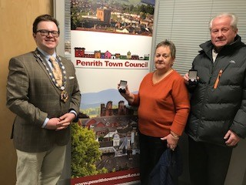
Councillor Scott Jackson
Mayor of Penrith and Town Council Chairman
(With retiring members of Penrith Allotment Association receiving “In Gratitude” medals from the Mayor)
Your Council
Reports from Council Committees
FINANCE COMMITTEE
In 2017-18 the Finance Committee, focussed on developing the internal finance systems which needed to evolve to support the Town Council’s growth and increased activities. The committee have implemented electronic banking systems that have meant that the Council can pay its suppliers promptly. By outsourcing the administration of the electronic banking, the committee created another level of internal control as a safeguard. The finance report systems are developing to allow for more timely reports to improve committee budget monitoring.
In September, the Council received the results of the externally audited, 2016-17 Year-end Annual Return. The Council received an unqualified report which confirmed that the Council’s accounts and all governance documents fulfilled the requirements of the Account and Audit Regulations. This means that the external auditor was satisfied with the Councils financial practises.
The Council underwent an interim half year report by the internal auditor for the period 1st April 2017 – 30th September 2017 for financial year ending 31st March 2018. The internal auditor recorded that Penrith Town Council was fully transparent with the Transparency Code requirements and had set a benchmark standard on the Town Council website. The auditor concluded that the Council maintained a high standard of recordkeeping, which simplified the audit process. The Council’s control systems were efficient and effective and gave the appropriate level of confidence, that the financial statements and reports reflected a true and accurate account of the Council’s finance and governance records.
The Finance Committee has been proactive in ensuring that the Town Council will be compliant with the new General Data Protection Regulations that come in to force in May 2018 and reviewed the Council’s resources to ensure that its obligations could be met for this new legislation, effective management of new assets and that the Council is equipped for growth.
In 2018-19, the Finance Committee will be responsible for the management of assets transferred from Eden District Council. The Council’s objective is to manage these services efficiently and be able to provide enhancements for them for the benefit of the users and the community. One example of this type of work that the Council does is the support that the Council have given to Penrith Allotment Association. The Association manage all the allotments in Penrith. Working in partnership with the committee we have been able to carry out several improvements to the allotments that will increase the revenue of the allotments. Having established an effective relationship with the association they are actively participating in Penrith In Bloom, maintaining an allotment diary and expanding the activities of the allotments to include increasing the number of beehives.
The Finance Committee develops the Council’s annual budget working closely with the Council’s committees. For 2018-19 the committee recommended that the increase in precept should only be increased to cover the transferred assets from Eden District Council: benches, war memorials, play areas, gardens, the bandstand and the Musgrave Monument. Eden District Council reduced the Council Tax it charged Penrith residents because these services would be provided by the Town Council. In agreeing to take on these services, the Town Council made a commitment that the precept would increase by no more than the amount that Eden District Council’s Council Tax was reduced. This meant that Penrith residents Council Tax for 2018/19 was no greater than in 2017/18.
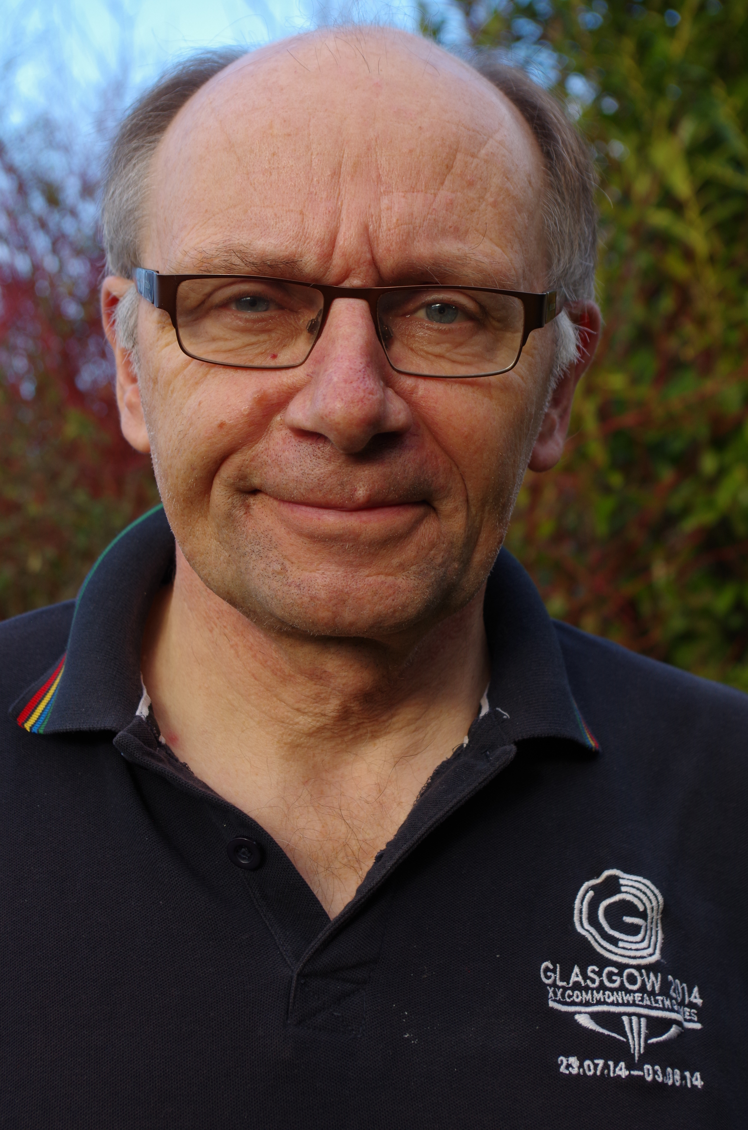
Councillor Ron Kenyon
Chairman Finance Committee
COMMUNITY, CULTURE AND ECONOMIC GROWTH COMMITTEE (CCEG)
2017 has been a busy and rewarding year for the CCEG Committee, we have committed funding to and supported the work of voluntary, community and charitable sectors, who work tirelessly to improve Penrith for residents and visitors and continued to build our relationships with key stakeholders within the town.
Penrith’s entry to Cumbria in Bloom 2017, was the most successful yet resulting in the town receiving the trophy for “Most Improved Town” for a second year, Penrith Bid won the “Business Improvement District” (BID) category and was awarded a gold medal for the exceptionally high standard of their entry. Special nominations were received by Costas restaurant and M and Co. “Pride in your Community” awards went to Penrith Community gardeners and “It’s your Neighbourhood Awards” received for Eden Mencap, Penrith Community Gardeners, Penrith Railway Station and Great Dockray Improvement team. Beaconside CE Primary won the Wildlife Habitat.
Penrith Bid went on to represent Cumbria in the Britain in Bloom finals in Cardiff and won the Best BID.
The wonderful team of community gardeners in Penrith who planted areas around town and at the railway station won the Community Champion award.
The number of awards won are testament to the community involvement and pride residents have in Penrith. The standard of our entry awarded Penrith with the honour of Penrith being asked to represent Cumbria in the 2018 finals of Britain in Bloom in the Large Town category.
Supported by a grant from Eden District Council, we have been able to help fund the successful Winter Droving event devised and organised by Eden Arts and to support the Eden Food and Farming Festival and Penrith Goes Orange, both organised by Penrith Chamber of Trade and Commerce, all helping to raise the profile of Penrith.
Penrith Town Council’s sponsorship scheme has also helped the forthcoming Penrith’s Lion May Day Festival, 7TH May 2018, a particularly well-loved date of the town’s calendar and the “Artists in Penrith” event organised and run by Eden Valley Artistic Network.
We also supported the Chamber of Trade with a scheme to enable businesses to improve the attractiveness of trading areas within the town and have supported their Christmas brochure to help generate footfall during the Christmas period. We have worked in partnership with the Penrith Business Improvement District to make the town sparkle with the wonderful display of Christmas lights.
The CCEG Committee are proud to have supported several organisations who are providing innovative and worthwhile projects within Penrith: the 106 Partnership, Penrith Bee Keepers, Eden Mencap, Penrith Remembers, Eden Credit Union, the Triple A Project, Cumbria Children’s Dyslexia Project, The Aspirations Project, Penrith Cricket Club, the Fairhill Group and North West Ambulance Charitable organisation to install three defibrillators around the town.
I would like to thank the community groups, the organisations and partners who are working together help make Penrith the unique special place it is. I would also like to thank the CCEG Committee members for their dedication and commitment to Penrith.
I would also like to encourage the people and organisations of Penrith, to continue in pulling together to ensure the good work of the Town Council continues, as together we grow and together we succeed.
Councillor Steven Connelly
Chairman CCEG Committee
PLANNING COMMITTEE
You will likely be aware that the major work of debating and deciding upon the acceptance of Planning applications in Penrith is the responsibility of the District Council.
As part of that process several bodies have a legal right to be notified and give an opinion, these are called statutory consultees, and this includes the Town Council. To this end the Town Council’s Planning Committee debates applications much as the Eden District’s Committee does but with a specific care to Penrith residents not necessarily possible for a district-wide institution.
This year the committee has debated and sent representations concerning a wide variety of applications and I am proud of the work we have done. In total we have responded to 157 applications within Penrith within the last year.
We consider it vital to understand the wider implications of each application from the impact on parking and highways to the added pressures put on healthcare and education provision.
Similarly, we have made sure the town is heard on the issues of Eden’s Local Plan, their Master Plan and their Vision Document as well as engaging positively with Cumbria County Council to ensure residents’ day to day experiences inform decision making at every level.

A vital part of this is making sure everyone feels welcome and able to contribute to our meetings and I want to highlight this opportunity. We are only as strong and influential as the people of Penrith make us so please do continue to tell us exactly what we need to know!

Councillor Scott Jackson, Mayor
Chair of the Planning Committee

Through the Localism Act, Penrith Town Council has been given powers to prepare a statutory Neighbourhood Development Plan (NDP) to help guide future development in Penrith. The NDP will be the product of the views of the local community and will not be something imposed on them by the Town Council. Therefore, the NDP is your opportunity to shape new development as, once the plan has been approved via a local referendum, hopefully to be held alongside local elections in May 1919, planning applications will be determined in accordance with the NDP.

In November 2016 Penrith Town Council set-up a Steering Group, made up of Town Councillors and volunteers from local interest groups representing education, business, the retail sector, the environment, young people and community groups, to develop a Neighbourhood Plan. The first meeting of the Group was held on 1st March 2017 and in the last 12 months the Group has met on 12 occasions (10 meetings and 2 workshops) with the result that Penrith’s NDP has taken a significant step towards completion of the first draft.

The steering group has analysed the results of the public consultation that took place from March to May 2017 and sourced documents issued by Eden District Council, and data collated by the County Council, to form planning policies for the future benefit of residents, employers, employees and visitors. Sustainability forms the backbone of the Plan which addresses housing, transport infrastructure, employment, leisure, parking and community facilities with the aim of directly influencing all future planning decisions, i.e. after the NDP has been adopted.

Over the last few months all the work has been drawn together and undergone checks to ensure the proposed policies don’t contravene National or Local Planning Policies.

During May and June 2018, we are on track to deliver the first draft of the Plan for informal public consultation at events and via the Town Council’s website: http://www.penrithtowncouncil.co.uk/neighbourhood-plan/

Hard copies will be made available for viewing at the Town Council’s offices and Penrith Library. All comments will be carefully considered by the Steering Group and incorporated as appropriate in the draft. Feedback from this informal consultation will help shape a revised plan that will be published for a minimum of six weeks’ formal consultation. Following Penrith Town Council’s formal consultation the Draft Plan will be submitted for review by Eden District Council who will then carry out a final period of consultation.

The Penrith NDP will then be subject to independent examination. If the examiner is satisfied that the Penrith NDP meets a set of basic conditions it will then be up to eligible voters in Penrith, through a referendum, to decide if the Penrith NDP is made part of the development plan for the area. A “yes” vote will impact planning decisions in Penrith for the next 15 years.

Through the Neighbourhood Development Plan the local community can contribute to addressing the challenges faced by Penrith and benefit from new opportunities to ensure that Penrith remains at the Heart of Cumbria and is a great place to live, work and visit. We hope that you will take the opportunity of the forthcoming consultations to ensure that Penrith has a vibrant and prosperous future.

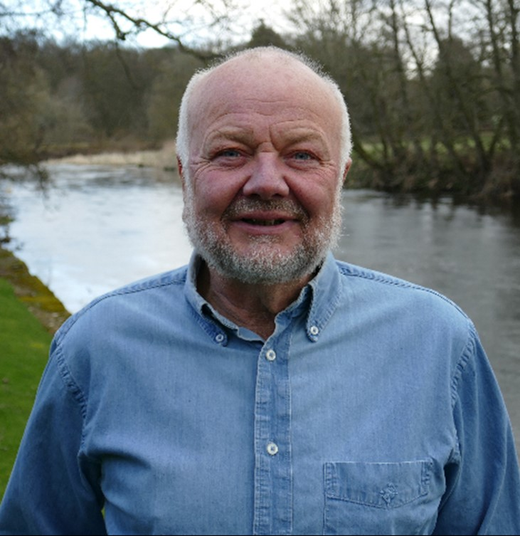

Councillor Peter G Baker

Chairman Neighbourhood Development Plan

Your Councillors
PENRITH NORTH WARD | PENRITH NORTH WARD
Councillor Jackson  Chairman  and Mayor | Councillor Whipp  Council Vice Chairman  and Deputy Mayor
10 Brentfield Way  Penrith  CA11 8DQ  07749 007 166 | 3-5 Harker Yard, Great Dockray  Penrith  CA11 7BL  01768 890255

NORTH WARD |  |  |  |  | CARLETON WARD
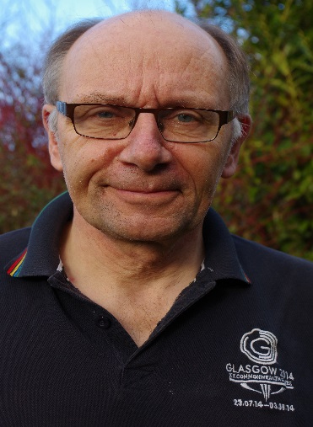
Councillor Kenyon |  |  |  |  | Councillor Lawson
30 Wordsworth Street  Penrith  CA11 7QY  01768 864728 |  |  |  | 3 Low House Farm Barns  Bowscar  Penrith  CA11 9NZ  07969 4815087

PATEGILL  WARD | PENRITH SOUTH  WARD | PENRITH SOUTH  WARD
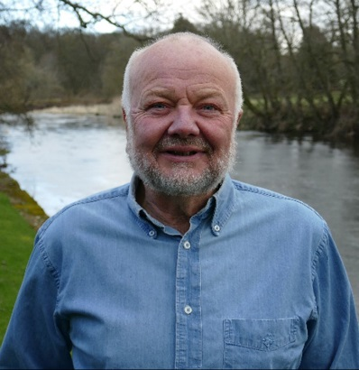 |  | 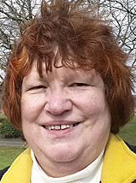
Councillor Baker | Councillor Burgin | Councillor Clark
10 Lowther Glen  Eamont Bridge  Penrith  CA10 2BP  07999777609 | 4 Greenacres Park Plumpton  Penrith  CA11 9PB  01768 894107 | 38 Castle Hill Road Penrith  CA11 7HA  07732 704133

PENRITH WEST WARD | PENRITH WEST WARD | PENRITH WEST WARD
 |  | 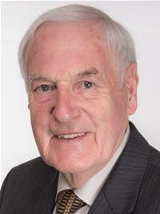
Councillor Connelly | Councillor Monk | Councillor Thompson
Flat 2,  19 King Street  Penrith  CA11 7AJ  07875761430 | Beaconside  Beacon Edge  Penrith  CA11 8BN  07795140504 | 49 Norfolk Place Penrith  CA11 9BE  01768 863937

Attendance 2017-18 Municipal Year

 | Total No of Meetings | Total No Attended | %age Attended
Cllr Ayres Resigned Sept 17) | 5 | 2 | 40%
Cllr Baker | 25 | 24 | 96%
Cllr Burgin | 15 | 14 | 93%
Cllr Clark | 5 | 4 | 80%
Cllr Connelly | 14 | 11 | 79%
Cllr Graham (Resigned Mar 18) | 11 | 8 | 73%
Cllr Jackson | 24 | 21 | 88%
Cllr Johnson (Resigned Sept 17) | 7 | 7 | 100%
Cllr Kenyon | 25 | 20 | 80%
Cllr Lawson | 10 | 6 | 60%
Cllr Lynch (Resigned Aug 17 | 3 | 2 | 67%
Cllr Monk | 5 | 3 | 60%
Cllr Thompson | 5 | 2 | 40%
Cllr Quinn (Resigned Oct 17) | 7 | 6 | 86%
Cllr Whipp | 10 | 8 | 80%

Here is a flavour of the activities the Council has been involved in that are generally adhoc, responsive, and informal, that hopefully go some way to make a difference…

INFORM

Methods used to inform the community include the Town Council’s website, Facebook and Twitter pages, press releases, posters, flyers, leaflets, infographics and face-to-face meetings at events and Councillor Surgery.

The Council’s website in 2018-19 will include an events calendar and community pages that will provide information about local groups, consultations and news etc.

CONSULT

Consulted with partners and stakeholders to discuss the development of a business plan for Thacka Beck and with residents local to Thacka Beck in Pategill about their aspirations for the green space.

Consulted with the community and visitors about the vital green spaces in Penrith - how valuable they are and what they should be used for.

Town centre policy consultation meeting with stakeholders for the development of the Neighbourhood Plan.

Consulted within some Penrith Wards as a tester survey to identify areas for improvement: potholes, dangerous pavements, blocked gullies, overgrown hedges and verges, litter, graffiti, dog fouling and raised the issues with the relevant authorities. Consequently, ward walks will commence in 2018 to monitor the wards.

Met with residents to look at valuable green spaces who agreed to take photographs of activities taking place on the green spaces and wild animals that inhabit these cherished spaces to provide evidence of their importance.

INVOLVE

Considered how Penrith open spaces that might be owned by PTC be used as a resource for a local forest school with a local practitioner.
Members of the community supported the activities needed for the development of the Neighbourhood Plan. Their help and support is very much appreciated.
Organised an open evening/funding forum providing opportunity for local groups to meet the Council and discuss how the Council can provide financial support for the projects. Over 20 groups attended. The Council would like to thank Penrith Lions for assisting the forum. Each group that did not fall under the Council’s remit were offered advice and guidance. A follow up meeting was arranged with Eden District Council to share information from the funding forum and assist in the progression of projects that were brought to the forum.
Promoted local projects and initiatives on social media
Attended Ullswater College mock interview day to provide guidance to year ten students as they prepare to leave school.
COLLABORATE
C

Forest School partner assisted the Town Council with projects for Penrith and Britain in Bloom projects.
Support provided to Penrith Lions as they develop the annual May Day festivities.
Assisted local builders who needed access to the allotments and a water supply, resulting in a donation to the allotment association.
Provided regular support to the new allotment association.
Arranged “In Bloom” open afternoons to encourage interest and ideas for Penrith in Bloom.
With representatives from the Cumberland Wrestling Association, we arranged the Mayor’s Civic reception, which has raised the profile of Penrith to an international level.
Connected with local groups – Penrith Refugees, Cumbria Youth Alliance, Thacka Glen Wildlife park conservation volunteers, Penrith reading group, Triple A project to name but a few...
Met with representatives from other authorities to discuss issues such as car parking, housing, highways infrastructure, highways problems, Eden District Councils Masterplan etc.
Met with representatives of County wide ‘Third Sector’ groups, to gather information and consider potential for future collaboration.
EMPOWER
Provided £5,000 to Fairhill Community Group for new playground equipment.

Provided financial support to make improvements to the allotments.
Earmarked funds to support improvements in Castle Park as part of the HLF Bid.
Provided numerous grants to help local organisations thrive and improve the quality of life for residents.
Connected a local business who want to give away end of season plants to local Gardeners.
Supported a community initiative that encourages people to litter pick and recognises local success by awarding certificates of gratitude from the Mayor.

