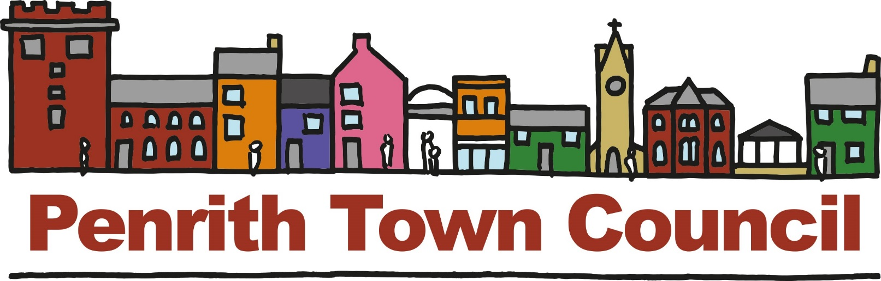
Unit 1, Church House, 19-24 Friargate, Penrith, Cumbria, CA11 7XR
Tel: 01768 899 773 Email: office@penrithtowncouncil.co.uk

COMMUNITY SPONSORSHIP

Penrith Town Council is supportive of the work of community and voluntary groups and charities operating within the Town and offer one-off community grants to such groups. Some groups provide annual events for the benefit of Penrith residents and have done so for several years. Some community and volunteer groups provide schemes of work or activities that enhance Penrith. this policy has been put in place to provide sponsorship opportunities for these groups.

WHO CAN APPLY FOR SPONSORSHIP
The sponsorship applicant must be able to demonstrate to the council that any sponsorship provided will be of benefit to the people living within the Town and that the benefit is commensurate to the expenditure.

Sponsorship will only be provided to recognised, bona-fide, non-profit making organisations or groups. Voluntary organisations, community groups and charities may apply.

Sponsorship cannot be made available to individuals, nor can they be made available to business or profit-making organisations. Limited companies may not apply.

WHEN CAN ORGANISATIONS APPLY FOR SPONSORSHIP?
The deadline for sponsorship applications for funding in 2017/18 are: 28th February
2018, 30th June 2018 and 31st October 2018. The request will be considered by the Council’s Community, Culture and Economic Growth Committee. Their decision will be final.

HOW MUCH CAN ORGANISATIONS APPLY FOR?
Organisations can apply for amounts between £100 and £5000.

REQUEST REQUIREMENTS.
A request must be made in writing and contain as a minimum the following information:
- Name of Organisation
- Lead person in the organisation with contact details
- Details of the project.
- Details of the exact use to which the Town Council’s funding will be put, if it is not for the entire project.
- And an agreement that the Councils sponsorship and/or logo be acknowledged in all promotion.

YOU MAY ATTACH A WRITTEN REQUEST TO THIS DOCUMENT or COMPLETE THE FOLLOWING REQUEST FORM.
3

Amount of sponsorship you are asking for: £

Details of project/events for which sponsorship is sought:
(Please include details on a separate sheet if necessary).

1. Your organisation
Name of your organisation

What is the legal status of the organisation?

In which year did the organisation start up?

Does it have a formal constitution?

2. Name of Contact and Position in the Organisation

3. Address for correspondence
Telephone:
Email:

4. Tell us about your project
- What are you applying for?
- Why do you need, this grant?
- Who will benefit?
- What do you hope to achieve?
- How many people will benefit?
- How will you measure the success of your project?

5. Details.
I. When does the project start?
II. What geographical area will it serve?

III. What is the total cost of the project?

IV. How much are you applying to the Council for and which specific elements of the project will it fund?

V. Is this a completely new project?

VI. Is the application for a once only cost?
VII. Does the application fulfil a need that would not otherwise be met?

VIII. If you are applying for less than the full project costs, how will you find the remainder?

IX. Where do you receive funding from?
(Include any support in kind from the District Council or County Council)

X. Please tell us who else you have applied to, and the results of other funding applications

XI. Have you received a grant from Penrith Town Council before?
If “Yes” when? And how much?

Is there any other information you wish to give?

7. Bank Details
Is your bank account in the name of your organisation and does
it require at least two signatories? YES/NO
Account Name:
Sort Code:
Account Number:
Bank/Building Society:

8. Checklist
Before signing please ensure that:

- You have answered all the questions and signed the declaration.
- You have enclosed a copy of your latest annual report.
- You have enclosed a copy of your latest audited accounts.
- You have enclosed your bank details.
- You have enclosed a copy of your organisations equal opportunities & diversity policy or organisational statement.

Declaration

When the application form has been completed an authorised Trustee or Official of the applicant organisation must sign the declaration below. All applications must be sent only by post to: -

The Economic Development Officer
Penrith Town Council,
Unit One, Church House,
19-24 Friargate,
Penrith, Cumbria,
CA11 7XR

Tel: 01768 425 853

Email: economicdevelopmentofficer@penrithtowncouncil.co.uk

I am an authorised representative of

To the best of my knowledge the information provided is correct.

If Penrith Town Council agrees to make a grant this will be used exclusively for the purposes described in this application.

Signed:

Date:

Position in organisation:
Data Protection and GDPR
The information that you have provided in your application will only be used for the purposes of considering your application and if approved, will be retained for six years with the Town Councils financial records. All personal data will be secured and not shared by a third party. By completing this application, you are consenting to the Town Council retaining your data. Please view the Councils Privacy Statement on the website or ask for a copy of the privacy statement.

OFFICE ONLY | CHECKLIST | ACTIONS
1 | All sections completed
2 | Sufficient detail
3 | Hard copy received with signature
4 | Function & Power available
5 | SLA required if greater than £1,000

